**EXPERIMET – 6**

**MEASUREMENT OF CAPACITANCE BY SCHERING BRIDGE**

AIM :

Objective :

To Determine the Capacitance of an unknown Capacitor.

Theory :

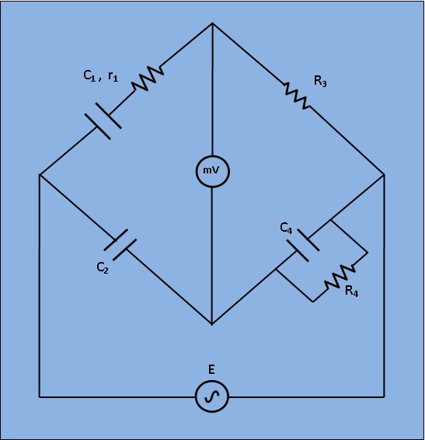

Fig 1: Circuit diagram for measurement of Capacitance by Schering Bridge

Let,

C1=capacitor whose capacitance is to be measured.

r1= a series resistance representing the loss in the capacitor C1.

C2= a standard capacitor.

R3= a non inductive resistance.

C4= a variable capacitor.

R4= a variable non inductive resistance.

At balance,

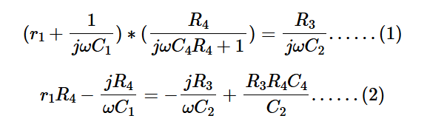

Or Equating the real and imaginary terms in equa. (2), we obtain

And, Two independent balance equations (3) and (4) are obatined if C4 and R4 are chosen as the variable elements.

Procedure :

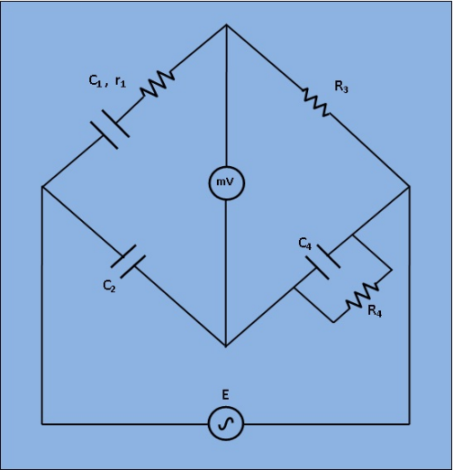

Fig. 1. Circuit digram of experimental set-up for Capacitance measurement by Schering Bridge.

1) Apply Supply voltage from the signal generator with arbitrary frequency. ( V =3v). Also set the unknown Capacitance value from 'Set Capacitor Value' tab.

2) Then switch on the supply to get millivoltmeter deflection.

3) Choose the values of C2, C4, R3 and R4 from the capacitance and resistance box. Varry the values to some particular values to achieve "NULL".

4) Observe the millivoltmeter pointer to achieve "NULL".

5) If "NULL" is achieved, switch to 'Measure Capacitor Value' tab and click on 'Simulate'. Observe the calculated values of unknown capacitance (C1) and it's internal resistance (r1).

6) Also observe the Dissipation factor of the unknwown capacitor which is defined as



Simulation :

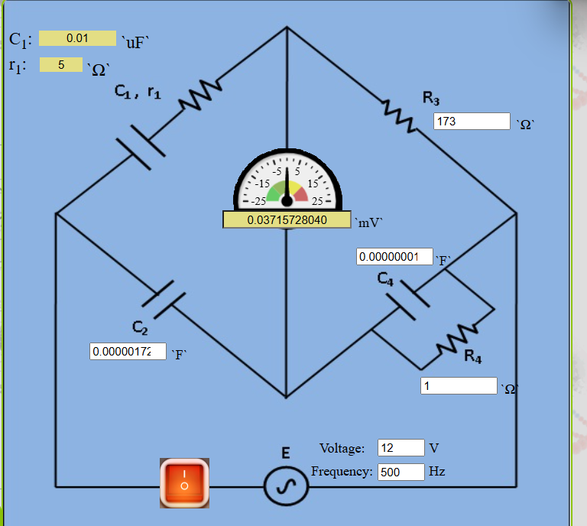

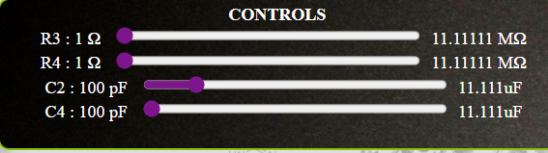

Set capacitor value

Measurement Capacitor Value

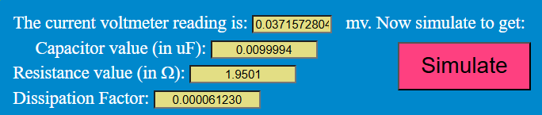

Result :

Thus the unknown resistance is found using Schering bridge